3WWDZ-16
Agriculture drone
User manual V1.0

TopXGun (Nanjng) Robotic Ltd,.Co
2020.4
Usage Reccomendation
TopXGun provides user with the following documents:
1. "Packing List"
2. "Quick Start Guide of Plant Protection UAV F16"
3. "User Manual of Plant Potection UAV F16"
4. "Usage Guidelines of Plant Protection Assistant APP"
Users are advised to use the packing list for item verification. Refer to "Quick Start Guide for Plant Protection UAV F16" to understand its operation. For detailed usage and functions, please refer to "User Manual of Plant Potection UAV F16" and "Usage Guidelines of Plant Protection Assistant APP".

Preface
The plant protection UAV F16 is a very mature multi-rotor aircraft, a leading in the industry in terms of function, appearance, control, safety and other aspects. There are certain usage risks of multi-rotor aircraft, please strictly follow the safety tips and user manual during the operation. The violation of regulations when using this aircraft may result in direct or indirect loss and damage.
Disclaimer
Please read the manual carefully before using the aircraft. Once the aircraft is used, it is deemed to be an acknowledgement and acceptance of all the content of this user manual. This aircraft is suitable for people with 18 years of age and older. TopXGun is not responsible for the loss of personal or property due to the following problems:
1. The user does not assemble and use the aircraft as required by this manual.
2. The user operates the aircraft in poor physical or mental conditions such as drinking, drug abuse, fatigue, etc.
3. The user actively or intentionally operates the aircraft to creat damage.
4. The user modifies the aircraft without using accessories from TopXGun, which is resulted in it could not work properly.
5. Injury caused by the user's misoperation or subjective misjudgment.
6. Damage caused by natural cause, such as aging of circuit and so on that affects the aircraft.
7. Damage caused by the user’s operation of the aircraft while knowing that it is in an abnormal working condition.
8. The user still operates the aircraft under severe weather conditions such as typhoon, hail and fog.
9. The user operates the aircraft in the magnetic interference area, radio interference area and government no-fly area.
10. The user operates the aircraft in case of poor visibility and occlusion of the line of sight.
11. The user operates the aircraft to cause the infringements by obtaining any data, image data and other infringement beUAViors.
12. Other losses that are not within the scope of the company's liability.

Safety Instruction Notes
1. Pesticide Usage
- When using the pesticide, please pay attention to wear protective equipment to prevent direct contact with the pesticide.
- Avoid the usage of the powder pesticide, it could reduce the service life of the spraying system.
- When dispensing, be sure to use clear water, otherwise it may be blocked by impurities. Do not remove any filter. Once the filter is found to be clogged, be sure to clean it before usage.
- After using the pesticide, please clean up the residual liquid in time. It is strictly forbidden to pollute the river and drinking water source, and ensure that it will not cause harm or impact on people, animals and the environment in the surroundings.
- The effect of the pesticide is closely related to the concentration of the pesticide, the spraying rate, the altitude of the aircraft from crops, the wind direction, the wind speed, etc. The above factors should be taken into account comprehensively when using the pesticide in order to achieve the best effect.
- Strictly follow the safety instructions of pesticide production company.
- Particular working fluids are prohibited.
2. Usage Environtment
- Always fly in an open space, away from the crowd.
- It is recommended to fly below 2000 meters.
- It should fly in the environment with the temperature between 0℃ and 40℃.
- It is recommended to fly in an environment with the wind speed below level 4.
- It is strictly forbidden to fly in rain, fog, snow or other extreme weather.
- It is strictly forbidden to fly indoors.
- It must fly in a legal area. Before flying in the legal area, please consult your local flight management department to comply with local laws and regulations.
3. Pre-flight Inspection
- Make sure that every device is fully charged.
- Make sure that all parts are in good condition. If there are some parts that are worn or damaged, please replace them before flight. Make sure that the landing gear and the tank are tightly mounted and all the screws are firmly tightened.
- Make sure that the propellers are not broken and firmly mounted, the propellers paddle and arm are fully extended, and the screws are tightened. Make sure the motors are clean and free of damage.
- Make sure the spraying system is free of blockage and works properly.
- Please calibrate the compass before flight.
4. Operation
- Keep away from the rotating propellers and motors.
- When folding, be sure to pay attention to the crushing danger.
- Be sure to fly under the take-off weight of 27.00KG to avoid danger.
- Operators must be professionally trained and pass the assessment, and the untrained personnel must not fly the aircraft.
- Make sure that the propellers are removed before calibrating and upgrading the firmware.
- When the aircraft and the remote controller are in frequency-connecting process, make sure that the propellers are removed and that human and animals are far away from the motor.
- Do not operate this product in poor condition such as after drinking, fatigue, illness, etc.
- If the operating environment does not meet the working condition of the radar module, the aircraft will not avoid obstacles when it returns automatically. If the remote-control signal is normal, the flight speed and altitude can be controlled by the remote controller.
- When working, be sure to turn on the remote controller first, and then turn on the power supply. After landing, turn off the power supply first and then turn off the remote controller.
- Please maintain the control of the aircraft throughout the process, and do not rely entirely on the information provided by the hand-held ground station.
- Obstacle avoidance and terrain following functions will not be available in the specific flight mode or flight environment. Please observe the attitude of the aircraft at all times and judge the flight condition reasonably to avoid obstacles in time.
5. Flight Restrictions and Local Laws
- Browse the official website of the Aviation Authority of your location for the latest list of restricted flight areas.
- The maximum control flight altitude is below 20 meters, please consult the local flight management department before taking off to comply with local laws and regulations.
Special precautions: Safety operating instruction notes includes but limited to above items.
Intellectual property rights
The intellectual property rights of this product and its manual belong to TopXGun (Nanjing) Robotics Co., Ltd. Without written permission, any organization or individual may not copy, reproduce and distribute them in any form. If quotation is required, the source should be indicated and the manual should not be modified, deleted or quoted contrary to its original intention.
About this manual
This manual is used as user guidance. Photos, graphics, charts and illustrations provided in the manual are only for explanatory and illustrative purposes, and may differ from the physical product. Please refer to the physical product.
Due to product upgrade or other reasons, the content of this document will be updated from time to time. Unless otherwise agreed, it is without further notice. Before using this product, please read this manual carefully.
Execution standard of this product: Q/TG 001-2018
Copyright. All rights reserved by TopXGun (Nanjing) Robotics Co., Ltd.

Contents
1. Product overview 6
1.1. Introduction to the remote controller 6
1.2. Introduction of the charger 15
1.3. Brief introduction of the smart battery 21
1.4. Introduction to the UAV 23
2. Flight 29
2.1. Flight notes 29
2.2. Indicator description 32
2.3. Operation description 33
2.4. Function description 40
3. Maintenance & Common Fault Elimination 50
3.1. Remote Control Maintenance & Announcements 50
3.2. Airframe Maintenance & Announcements 50
3.3. Motor Maintenance & Announcements 50
3.4. Propeller Maintenance & Announcements 51
3.5. Battery Maintenance & Announcements 51
3.6. Plug Connection Maintenance & Announcements 53
3.7. Spray system Maintenance & Announcements 54
4. Appendix 54
4.1. Specification Parameters 54

Product overview
The agricultural plant protection 3WWDZ-F16is a convenient, efficient and economical folding four-axis plant protection UAV, which is specially designed for agriculture. The downward flow generated by its rotor is helpful to the penetration of the pesticide to crops and has good preventive treatment effect. It adopts convenient surrounded airframe design and modular maintenance design, the precise metering spraying system of its double pumps supports one-click setting of the dosage per mu, and it is equipped with auxiliary operating systems such as FPV and obstacle avoidance, which make the spraying machine simple and safe to operate.The intelligent data platform based on 4G high-speed network can efficiently transmit plant protection operation data,and the background system performs synchronous analysis and processing to make the management real-time visible and controllable.

Introduction to the remote controller
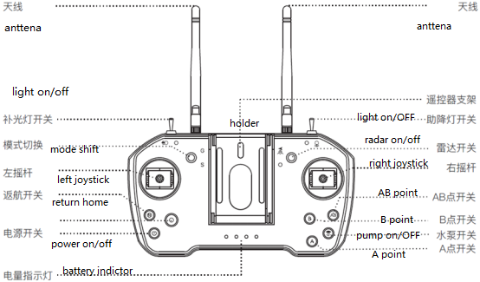

1.1.2. Definition of battery capacity display
Battery capacity corresponding table of the battery indicator light:
No. | Battery power indicator light | Corresponding state | Remaining battery capacity
1 | Off | Off | Turn off
2 |  | One light flickers. | 0-10%
3 |  | One light is always on. | 10-25%
4 |  | Two lights are always on. | 25-50%
5 |  | Three lights are always on. | 50-75%
6 |  | Four lights are always on. | 75-100%

Antenna placement
The antenna of the remote controller adopts a foldable design, and the received signal strength in different positions is different. It is recommended to keep the antenna of the remote controller perpendicular to the ground when controlling the UAV. In this case, the signal strength is the largest. The position or distance between the controller and the UAV is adjusted in time for the remote-controlled flying to ensure that the UAV is always in the optimal communication range. Therefore, it is necessary to avoid the antenna of the remote cotroller pointing to the UAV during the flight, the right operation is as shown in Figure 1-1-3.

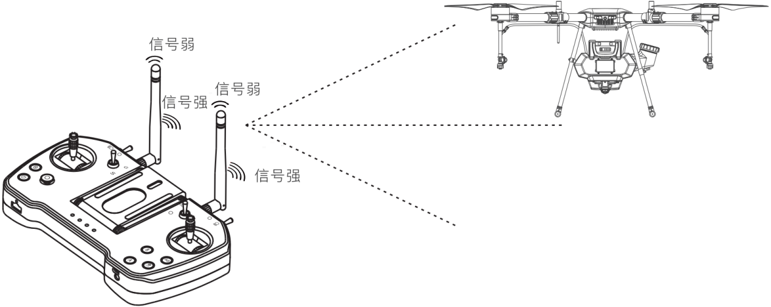

Figure 11-3 Signal strength of the remote controller
Special considerations:
1. During the flight, do not fold the antenna to avoid obstruction blocking between the remote controller and the UAV, otherwise the quality of signal transmission will be seriously reduced.

Charging steps
Step 1: Select a charger suitable for the remote controller (5V-2.0 A).
Step 2: Connect the micro-USB interface on the back of the remote controller with the micro-USB charging cable attached with the device, and connect the other end to the USB interface of the charger.
Step 3: Connect the charger to the adapted AC power supply, and the button“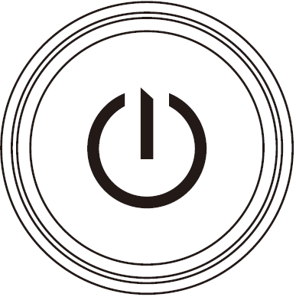”flickers while charging. When the button“”is off, the charging is completed.
Special considerations:
1. Do not charge by using the USB interface with the rated voltage exceeding 5V.
2. The remote controller should be in the situation that the charging current should not exceed 2A.
3. If the remote controller is found to UAVe odor, smoke or liquid leakage, sent the remote controller back to inspect and identify after stopping charging.
4. Do not charge the remote controller when the ambient temperature exceeds 60℃.
5. When charging, please keep away from the areas that the infants and children can touch, and try to keep the personnel accompany as much as possible to prevent accidents.
1.1.5. Frequency-matched steps
Tip: Before the delivery, the UAV and remote controller UAVe been matched in frequency.
Step 1: Keep the remote controller and receiver at a distance of about one meter and turn off the power supply of the remote controller.
Step 2: When the receiver is powered on, the frequency-matched cable is inserted into the receiver, and the terminals MODEKEY and GND of the receiver are short-circuited for 2 seconds, and the green light of the receiver flickers and enters into the frequency-matched mode.
Step 3: Turn on the remote controller, the receiver turns from the green light flickering to the long green light, and the remote controller produces 4 fast sounds "drop", which represents the success of matching the frequency.
Special considerations:
1. Ensure that the propeller of the UAV has been removed and that the human and animals are kept away from the motor of the UAV during the frequency matching.
2. When the frequency is matched successfully, restart the power supply of the receiver and try to operate the transmitter to confirm the success of matching the frequency.
1.1.6. Specification parameters
Items | Parameters
Frequency range | 2.4000GHz - 2.4830GHz
Power of the transmitter | 20dBm
Receiving sensitivity | -118dBm
Effective communication distance | The maximum is 10km (Open outdoor, non-interference)
Battery type | Built-in 1S lithium battery with 3.7V and 3000mAh
Battery life | 25 hours
Charging interface | Micro-USB interface
Body size | 225x123x35mm
Body weight | 560g

charger introduction
TC2604 Smart Charger is a four-channel lithium polymer battery charger with a maximum charging current of 50A and supports two modes of fast charging and slow charging.

instruction
See figure 1-2-1、figure 1-2-2

Figure 1-2-1 Charger Component

- Operation interface 2. Handle 3. Battery charging port 3 4. Battery charging port 4 5. Battery charging port 2 6. Battery charging port 1 7. AC input port 8. Ground terminal

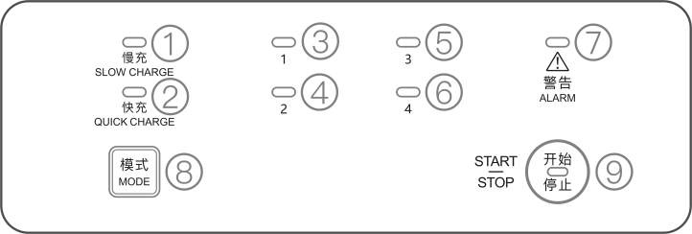
Figure 1-2-2 The Operation Panel

1. Slow Charge indicator 2. fast Charge indicator 3. Charge indicator 1 4. Charge indicator 2 5. Charge indicator 3 6. Charging indicator 4 7. Operating indicator 8. Charging mode button 9. Power on/off button

Function Description
1.2.2.1 Status indicator LED Descriptions
- Start and self-check
First check whether all the terminals are correctly connected, then press “start/stop”button on the operational panel. The battery charge LED, Quick/Slow charge LED will be turn into green, and the charger status LED will flashes red, green and blue alternatively. The product complete normal start and self-check along with the end of “D-”.
Charging logic
Charging Mode | Battery capacity>12000mAH | Battery capacity<=12000mAH
Fast charge | The charger will charge one battery at a time, according to the remaining capacity from high to low. | The charger will sort the batteries according to the remaining capacity from high to low, and can charge two batteries with higher power at the same time.
Slow charge | The charger automatically divides the batteries into two groups, and each group will be sorted according to the remaining capacity. The charger will charge the batteries with low remaining capacity first, when the battery has the same remaining capacity as the ones in another group, then two groups will be charged simultaneously until the end of charging.

3) Description of the battery charging status indicator (the quick or slow charging indicator LED will remain on according to the selected mode)
LED flash rules | warning | Description
off | / | No battery access to the corresponding numbered socket
Yellow Light Solid On | / | The battery accessed to the corresponding numbered socket, wait for charging
Green Light Breathing | / | The corresponding numbered socket is in slow charge mode.
Green Light Fast Flash | / | The corresponding numbered socket is in quick charge mode.
Green Light Solid On | / | The corresponding numbered socket is fully charged.
Yellow Light Continuous Single Flash | / | Battery temperature is too low, the charging current is limited.
Yellow Light Continuous Double Flash | / | Battery temperature is too low, charging is prohibited.
Yellow Light Continuous Triple Flash | / | Battery temperature is too high, charging is prohibited.
Yellow Light Continuous Quadre Flash | / | Large difference between output voltage and battery voltage.
Red single flash | D.D.D… | Batteries not plugged in/unofficial batteries/communication abnormalities
Red double flash | D.D.D… | Batteries with different voltages are mixed
Red triple flash | D.D.D… | Faulty setting on BMS side of battery
Red always on | D.D.D… | Output overvoltage, other hardware failure

- Charger state indicator
LED flash rules | warning | instruction
Red, yellow and green flash alternately | / | Turn on and self check
Green breathing | / | Firmware updating
Green always on | / | Firmware update finish
Green flash | / | Work log extract
Green always on | / | Work log extract done
Green always on | / | Self check finish and sucess
Yellow single flash | / | Charger temperature is too high, power drop work
Yellow double flash | / | Input voltage undervoltage alarm
Red triple flash | / | Input voltage high voltage alarm
Red signal flash | DD.DD.DD… | temperature is too high, fan is abnormal (total fault)
Red double flash | DD.DD.DD… | Charger input voltage abnormal（less volatge）
Red triple flash | DD.DD.DD… | Charger input voltage abnormal（over voltage）
Red always on | DD.DD.DD… | Broken, abnormal

- Fast/slow charge indicator instruction
Fast charge indicator | slow charge indicator | Battery state indicator | warning | state
Green always on | / | Green light flash quickly | / | Fast charge state
/ | Green always on | Green breathing | / | Slow charge state

Charge steps
Step 1: Connect the power cord to the charger's power port, and connect the other connector to the AC power supply（100-240V，50/60Hz），
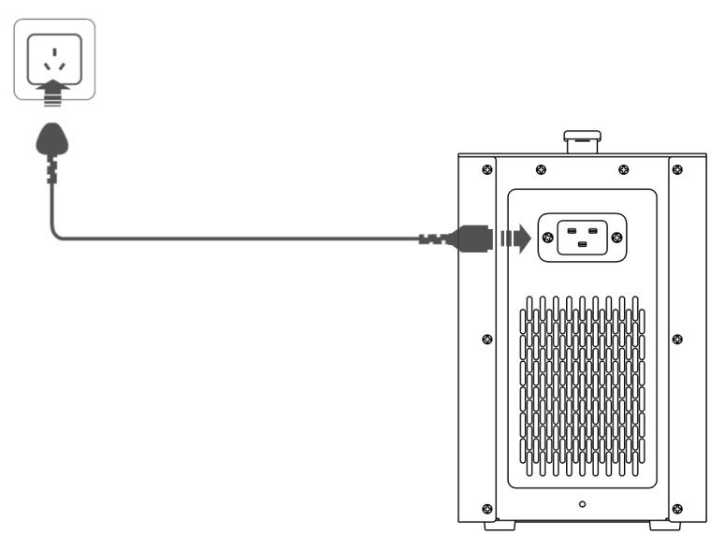

Figure 1-2-3 charger power cable connect
Step 2: Connect the battery: Please connect the charger wiring to the battery charging port according to the connection mode shown in the figure below.See Figure 1-2-4.
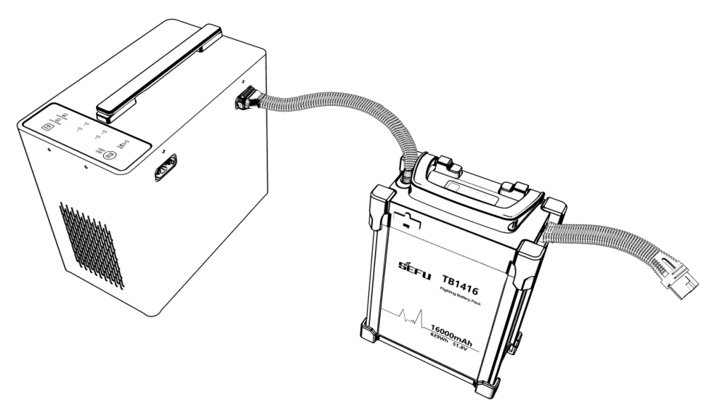
Figure 1-2-4 battery connect
Step 3. After making sure that all wires are connected correctly, press the "Start/stop" button in the operation panel, and the charger will start self-check.The indicator light in the corresponding channel of battery insertion is always on yellow light, and the alarm indicator is off when the self-test is normal. If the self-test is abnormal, please refer to the description section of the indicator state.
Step 4. Selection of working mode: After the charger self-test is completed, the charger defaults to fast charging mode. You can select fast charging mode or slow charging mode by pressing the button.
Step 5. Press the "Start/Stop" button in the operation panel to shut down the battery after charging, unplug the AC power cord, and unplug the battery.

The following rules shall be followed for battery plugging and unplugging;
Charge mode | Battery state | Channel indicator state | Plug or unplug battery intruction
Fast charge | Full battery | Channel light green always on | Unplug battery directly
 | Battery wait charging | Channel yellow green always on | Unplug battery directly
 | During charging | Green flash | If plugging and unplugging is needed, please press the start and stop button before plugging and unplugging. direct plugging and unplugging are prohibited if not press stop button
Slow charge | Full battery | Channel light green always on | Unplug battery directly，After plugging and unplugging, the charger will reorder the battery
 | Battery wait charging | Channel yellow green always on | Unplug battery directly，After plugging and unplugging, the charger will reorder the battery
 | During charging | Green flash | If plugging and unplugging is needed, please press the start and stop button before plugging and unplugging. direct plugging and unplugging are prohibited if not press stop button

Special Notes:
1. Do not use the product in the environment of direct sunlight, humidity, high temperature, dust, vibration and lightning
2. Products should be kept away from dangerous substances such as high pressure, heat source, corrosive agent, flammable gas, etc., and must be used at appropriate ambient temperature (5-45 ℃ is recommended).
3. Products should be placed in a stable horizontal position, and good ventilation and heat dissipation conditions should be ensured when working.
4. When charging this product, please strictly follow the battery safety instructions and cautions.
5. Before connection, please ensure that all ports and input lines of modules and batteries are free from obvious defects such as clog, damage, breakage and short circuit.
6. Before use, please ensure that the power supply line has enough capacity to avoid overheating or even fire caused by insufficient capacity, especially when two or more equipment are used at the same time.
7. Do not pull out the input wire during the product operation, and pull out the battery in time after charging.
8. Make sure to connect the battery before starting to charge.
9. The design of this charger is only applicable to the supporting battery of the aircraft. If the user USES the charger for purposes other than those listed in the manual, the Company shall not assume any responsibility.
10. Do not use the charger unattended. If there is any abnormal function, please stop charging immediately.
11. In case of fire, do not use liquid extinguishing media to avoid electric shock. Use dry powder extinguishing media correctly.

Charger parameter
item | spec
input | 100V-240V-11A 50/60Hz
output | 2600W
Charging current | Max 50A
Work temperature | 5℃~45℃
Work humidity | 0%~75%
Storage temperature | -10℃ ~ 70℃
Store humidity | 0%~75%
Voltage self test | support
Protection | 过流保护  过温保护  过压保护  短路保护  反接保护
Size | 5.65kg
Weight | 295*275*320mm

Battery introduction

Battery spec
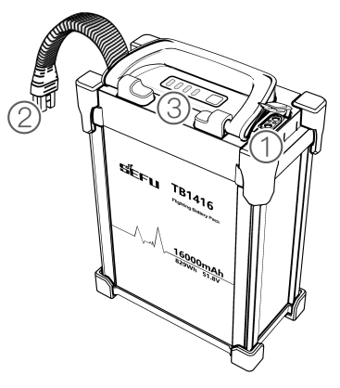
1、charge port 2、output port 3、indicator

Figure 1-3-1 battery

Spec
Item | Spec
Capacity | 16000mAh
Standard voltage | 51.8V
Standard charging current | 16A（environment temperature：25±5℃）
Max charging current | 8A，environment temperature：0~10℃  16A，environment temperature：10~20℃  32A，environment temperature：20~45℃
Limit charge voltage | 58.8V
Max discharge current | 80A，environment temperature：-10~0℃  160A，environment temperature：-0~10℃  240A，environment temperature：10~60℃
Working environment | 0~45℃（charging）  -10~60℃（discharge）
Storage environment | -20~25℃（1 year）
weight | 5.65Kg
Special considerations:
1. Before use, make sure the battery is fully charged. When the battery is not used for a long time, please charge and discharge it to the storage voltage with a special charger and store it in a dry and ventilated environment.
2. The battery needs to be charged with a special charger (TC2604), and the charger can not be replaced by oneself in order to avoid accidents.
3. The battery should be taken and placed lightly to avoid collision with hard objects. It is strictly forbidden to hold the cables or the rubber belts.
4. The battery should not be used if it emits odor, heat, distortion, discoloration or any other abnormal phenomena.
5. If the battery is in use or charged, it should be removed immediately from the appliance or the charger and stopped using.
6. Before use, it is necessary to ensure that the surface temperature of the battery does not exceed 35 ℃, and after normal flight, the surface temperature of the battery should not exceed 55 ℃.
7. When the connection between battery plug and UAV plug is loose and the inner wall is oxidized and blackened, the plug must be replaced.
8. The cap should be closed when the battery is not charged.
9. When the ambient temperature is lower than 10 ℃, the flight time will be shortened, which is a normal phenomenon.
10. After use, when there is the residual pesticide on the surface of the battery, it should be wiped in time to avoid pesticide corrosion.
11. It is forbidden to use in the environment of strong static electricity, magnetic field or high voltage line.
12. It is forbidden to pierce the battery shell with the nail or other sharp objects. It is forbidden to hammer or pedal the battery.
13. If the electrolyte enters the eyes after the battery leaks, do not wipe it, rinse it with water and seek medical assistance immediately. If it is not handled in time, the eyes will be hurt.

Aircraft introduction

aircarft
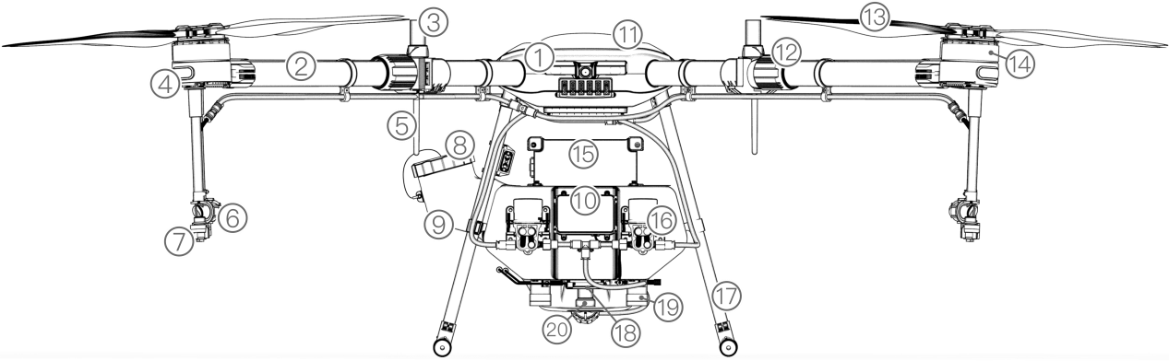
Figure 1-4-1 Main view

1、FPV 2、arm 3、RTK antenna 4、indicator 5、RC antenna 6、pressure valve 7、nozzles 8、water inlet 9、tank 10、avoidance radar 11、frame body 12、arm fasten part 13、propeller 14、motor 15、intelligent battery 16、pump 17、land gear 18、terrain folllow radar 19、flow sensor 20、land lamp 21 avoidance radar 22 water outlet
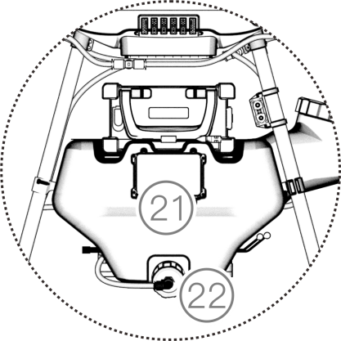
Figure 1-4-2 Rear view of the pesticide box

Debugging preparation

Arm unfoldable
Step 1: Take out the drone F16；
Step 2 :Expand the arm to 180 degrees, which is from the folded state of the arm in Figure 1-4-3 to the unfoldable state of the arm in Figure 1-4-4
Step 3 :Lock screw as shown in the following figure 1-4-4.
Step 4: Unfold the propeller to 180°，as shown figure1-4-5。
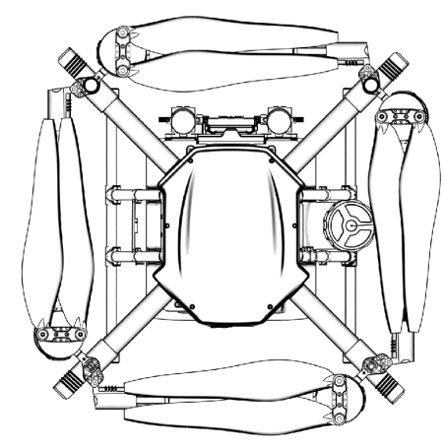
Figure 1-4-3 arm unfoldable

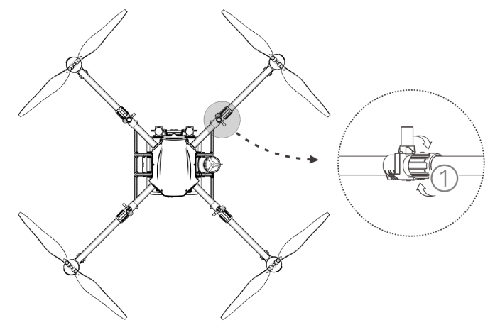
Figure 1-4-4 arm foldable
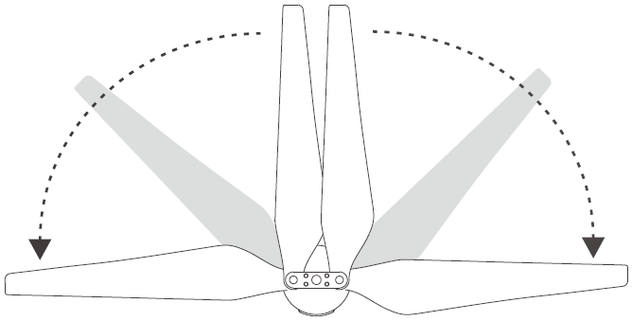
Figure 1-4-5 unfold the propeller

Install battery
Be sure to use the battery for this UAV and check the battery capacity to ensure that it meets the take-off conditions.
Step 1: Place the battery in the battery tank of the pesticide box and ensure that the battery is fixed by the battery pressing block.
Step 2: The battery is fixed with two battery pressing blocks and rubber straps to ensure its reliability as shown in Figure1-4-5.

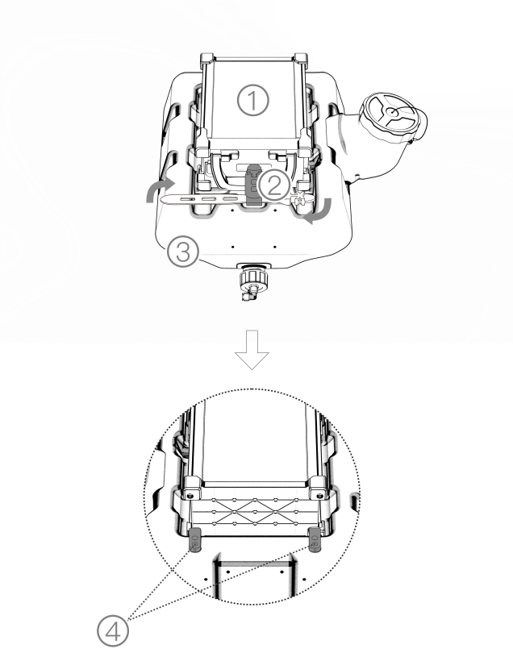
1、battery 2、battery strap 3、tank 4、battery feet

Figure 1-4-6 install battery state

Drone calibration
Compass calibration
Step 1: Push the throttle lever to the lowest position.
Step 2: Quickly switch the “mode switch” between the lowest position “S” and the highest position “G” for about 6-10 times until the blue light of the status indicator flickers.
Step 3: Place the UAV head forward and horizontally, then rotate it slowly clockwise for at least one turn until the green light of the status indicator flickers.
Step 4: Put the UAV head down, the body is vertical, and then rotate slowly clockwise for at least one turn until the green light of the status indicator is on for 4 seconds.
Step 5: If the red light of the status indicator is on for 4 seconds, which represents the calibration fails. Repeat steps 2-4 until the operation is successful. The operation diagram is shown in Figure 1-4-7.

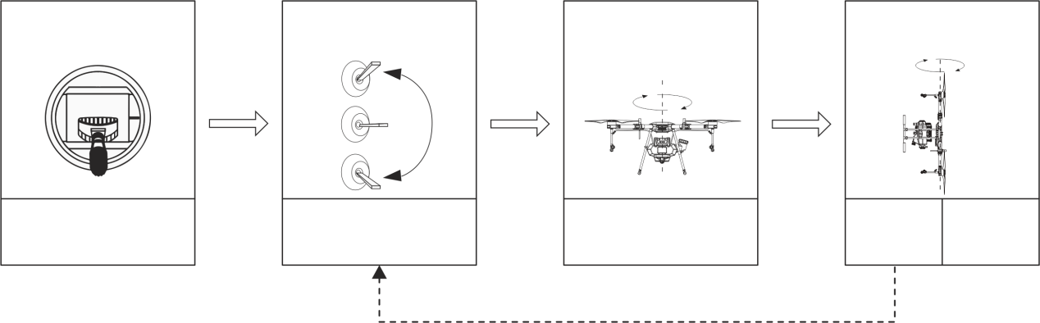
recalibrate
Rotate horizontally clockwise at least once
Till flash blue light
Green light 4s
Till green flash
nose down and turn clockwise at least once
Throttle lowest
Red light
4s

Figure 1-4-7compass calibrate
You aslo can make compass calibrate by app
Step 1: Click app right corner 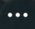 enter into setting interface，click enter into flight setting；
Step 2: click 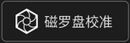 ，drone will show blue light。
Step 3: Place the UAV head forward and horizontally, then rotate it slowly clockwise for at least one turn until the green light of the status indicator flickers.
Step 4: Put the UAV head down, the body is vertical, and then rotate slowly clockwise for at least one turn until the green light of the status indicator is on for 4 seconds.
Step 5: If the red light of the status indicator is on for 4 seconds, which represents the calibration fails. Repeat steps 2-4 until the operation is successful. The operation diagram is shown in Figure 1-4-7.

Special considerations:
1. Before calibration, the propeller of the UAV should be removed.
2. Do not calibrate it in areas with strong magnetic fields, such as magnetic mines, parking lots, building area with underground steel bar and so on. During the calibration, do not carry ferromagnetic materials such as keys, mobile phones and so on.
3. Do not calibrate near the large metal.
4. Do not calibrate the compass indoors.

Flow calibrate
When using the UAV to perform the spraying operation for the first time, it is necessary to calibrate the flow rate, otherwise the operation effect will be affected.
Preparing before calibration: press the button“”, start the pesticide pump on the ground and discharge the air in the pipeline
STEP 1: Add about 5000ml of pesticide liquid into the operation tank.
Step 2. Plan a regular land of no less than 5 mu, the length of the land is no less than 100 meters, and the liquid level switch is selected to "no surplus".
Step 3. Upload the route and start the operation of the UAV until the breakpoint of the pesticide is recorded.
Step 4. After the UAV returns, the APP will pop up the dialog box of “Flowmeter calibration”.
Step 5. Enter "5000ml" in the dialog box of "Flowmeter calibration"
Step 6. The calibration is completed.
Special considerations:
1. After replacing different nozzles, it needs to be calibrated again.
2. After replacing the pesticide liquid with different viscosity, it needs to be calibrated again.
3. After the operation, the error between the actual operation area and the theoretical operation area is more than 10%. It needs to be calibrated again.

flight

2.1 Flight notes
According to the regulations of the International Civil Aviation Organization (ICAO) and national air traffic control on airspace control and the regulation of UAVs, UAVs must fly in the prescribed airspace. For flight safety, flight restriction functions, including altitude and distance restrictions and no-fly area, are enabled by default to help users use the product more safely and legally.
Under the condition of GPS, the no-fly area affects the flight together with altitude and distance restriction, and the airspace of the UAV is the overlap area of all restricted airspace.But in the absence of GPS, the altitude of the UAV is not limited by the Plant Protection Assistant APP.
2.1.1. Altitude and distance restriction
Altitude restriction is used to limit the flying altitude of the UAV, and the maximum radius is used to limit the flight distance of the UAV. Users can set it in the plant protection assistant. The default maximum flight altitude is 20 meters, which is shown in Figure 2-1-1.
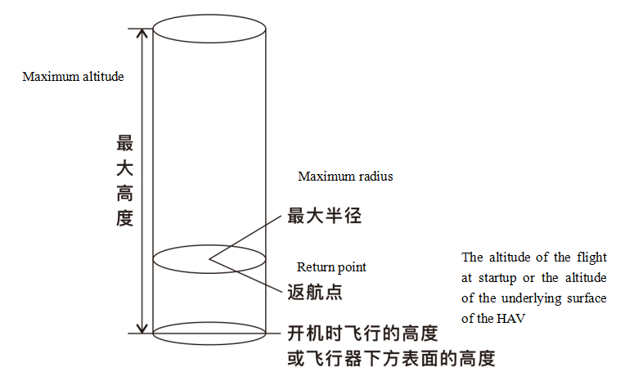

Figure 2-1-1Altitude and distance restriction

GNSS state | Flight mode | Flight limit |  | warning
With GNSS | GPS mode  auto mode | Max height | 20m | Will UAVe warning
 |  | Max radius | 9999m | Will UAVe warning
 | Attitude mode | Max height | 20m | Auto shift to GPS mode,has warning
 |  | Max radius | 9999m | Auto shift to GPS mode,has warning
Without GNSS | Attitude mode | Max height | No limit | No limit
 |  | Max radius | No limit | No warning

No-fly area and restricted area
The areas include airports restricted flight areas and special flight restricted areas. For more details, please refer to special flight restricted areas.

http://www.caac.gov.cn
Restricted area (when GNSS is valid): The ‘no-fly ’area is defined by a circle with special location as the centre point and R as radius. The UAV is not allowed to fly within no-fly zone. For the R value, please refer to the specific rules for the restricted area as shown in Figure 2-1-2.

No fly zone
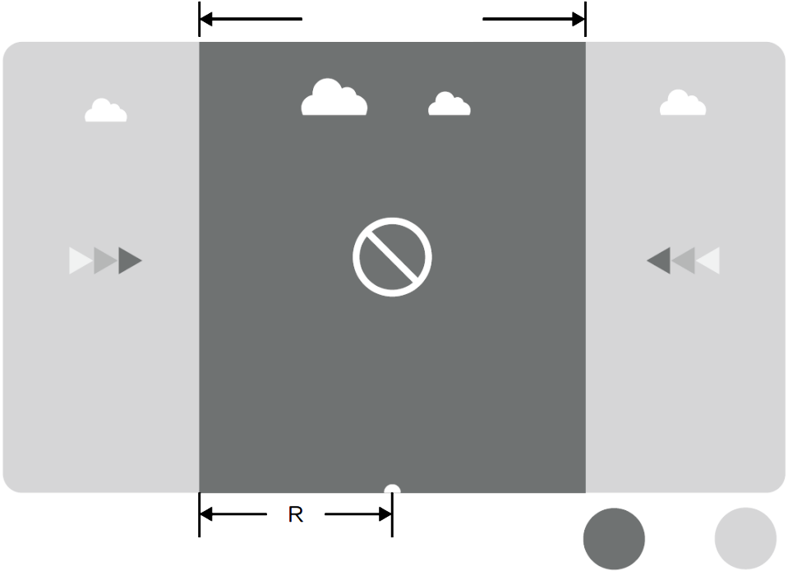
Free fly
No fly

Figure 2-1-2 No-fly area and restricted area

GNSS signal is normal
area | Special area with flight restriction | Status indicator light for the UAV
No fly | The motor can not be started. | The red light is always on.
 | If the UAV flies in the state without GNSS, it will land automatically immediately after it is converted to the state with GNSS, and stops the motor automatically after landing.
Free fly | The UAV can fly normally without flight restrictions. | There is no warning of red light.

Special considerations:
1. In order to ensure the flight safety, please try to avoid airports, highways, railway stations, subway stations, urban areas and other flying areas for flight and try to fly within the visual range.

Indicator description
For the first flight test, it is recommended to understand the meaning of the flight status indicator to ensure the flight safety.

No. | state | content | warning
1 | normal | Pass the self-check of power-on, GPS starts to search the satellite | The blue light double flashes.
2 |  | The preparation is completed, the UAV is ready to take off. | The blue light is always on.
3 |  | Take off | The red light is always on at nose direction.  The green light is always on at the oppsite of nose direction.
4 |  | Mode shift | The green light flashes for 5 seconds.
5 |  | Magnetic compass calibration (Horizontal) | The blue light flashes twice in one second.
6 |  | Magnetic compass calibration (Vertical) | The green light flashes twice in one second.
7 |  | The calibration of the magnetic compass is successful. | The green light is on for 4 seconds.
8 | Abnormal | The calibration of the magnetic compass failed | The red light is on for 4 seconds.
9 |  | The self-check is passed. | The red light is always on.
10 |  | Low voltage/ First level of the battery capacity | The red light flashes slowly.
11 |  | Low voltage/ Second level of the battery capacity | The red light is always on.
12 |  | IMU fault | The red light is always on.
13 |  | Barometer fault | The red light is always on.
14 |  | GPS fault | The red light is always on.
15 |  | Independ magnetic compass fault | The red light is always on.
16 |  | Motor fault | The red light is always on.
17 |  | Lose control of RC | The red light is always on.

Operation description
2.3.1. Inspection before the flight
Please check the following to avoid the flight accident.
1. Place the UAV in the open operation area with the user facing the tail.
2. Make sure that the battery of the UAV IS installed properly and tied up with battery straps.
3. During the flight, it is necessary to turn on the remote controller before connecting the power supply of the UAV.
4. Make sure that the battery of the UAV and that of the remote controller are adequately charged and the pesticide required for spraying are sufficient.
5. Make sure that the motor and propeller rotate correctly, the structure is stable, all arms and paddles UAVe been fully deployed, and the arm sleeve has been locked.
6. Make sure that the spraying pipe is free of blockage and leakage, and the sprinkler can spray water normally. If there is no pesticide during ground testing, please unscrew the pressure relief valve on the side of the sprinkler manually. After removing the air bubbles, then tighten the pressure relief valve, and the sprinkler can the spraying will resume.

Unlocking and locking

Unlock
As shown in the following Figure 2-3-1, the operation of unlocking is performed. While unlocking, the motor will rotate in the order of No. 1 motor, No. 2 motor, No. 3 motor and No. 4 motor. When the No. 1 motor starts to rotate, push the throttle gently and all the motors will start at the same time.
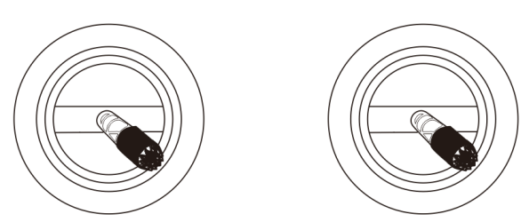
Figure 2-3-1 unlock

Lock
The UAV supports two active locking methods:
- Perform the operation shown in Figure 2-3 2 to lock.
- After the UAV lands, the throttle stick should be kept at the lowest position for at least 3 seconds, and then the UAV is locked automatically.

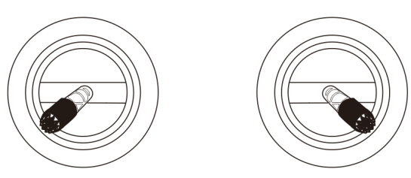
FIGURE 2-3-2 LOCK

Take off and land

Take off
Step 1: Turn on the remote controller by clicking the button“” and pressing the button“” for 2 seconds.
Step 2: Turn on the power supply of the plant protection UAV.
Step 3: The distance between the manipulator and the UAV should remain more than 10 meters. Enter the operation interface of the plant protection assistant APP to ensure that the signal of GNSS is good, and the status indicator light of the UAV has no red light warning;
Step 4: Perform the unlocking work, the motor of the UAV will start one by one, then push the throttle lever upward slowly, then the UAV takes off.
Step 5: After the throttle stick is returned to its neutral position, the UAV maintains the current altitude and hover as shown in Figure 2-3-3.

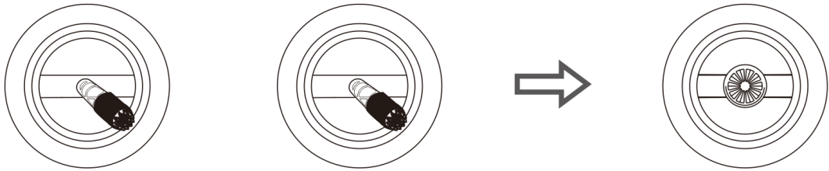
throttle
Figure 2-3-3 unlock and hover

land
Step 1: Slowly pull down the throttle lever, and the UAV land on the ground.
Step 2: After the UAV lands, place the throttle stick to the lowest position, and then perform the locking action as shown in Figure 2-3-4.
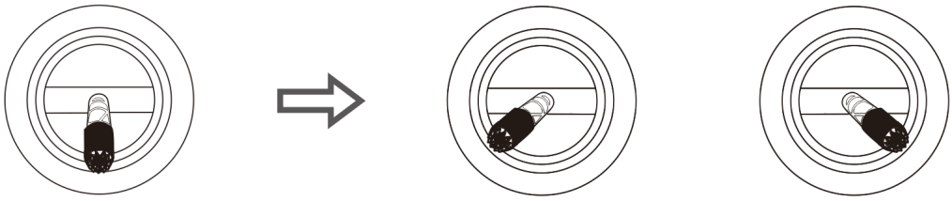

Figure 2-3-4 land and lock

Special considerations:
1. For the first test flight, the flight altitude shall not exceed 4m.
2. Do not fly beyond visual range for the first test flight.
3. During the flight, if there is any voice or red warning on the status indicator of the UAV, please make it land in time and check according to the warning message of the plant protection assistant.

GPS mode

GPS mode introduction
The GPS operation mode has the characteristics of simple operation and short preparation time. It is suitable for plot operations of small, irregular and complex terrain. In the GPS mode, the maximum flight speed of the UAV can be set to 8 m/s. The spraying speed of pesticide liquid is related to the flight speed, which means the faster the flight speed of the UAV, the larger the flow of pesticide liquid. When the UAV hovers, the pesticide liquid shuts down automatically.

Operate steps
Step 1: Before taking off, click the button “” to test the pesticide liquid spraying of the UAV and check whether there is air in the pipeline.
Step 2: The UAV takes off and fly to the area to be sprayed.
Step 3: Press the spraying button “”to control the UAV’s heading to the operating area and start the operation.

Special considerations:
1. During the operation, make sure that the UAV is in sight.

AB point mode

AB point mode introction
The AB point operation mode suits the use in the regular area as its operation steps are relatively few. In AB point operation mode, the UAVcan operate automatically after recording the points A and B, and the pesticide liquid can be closed automatically when the line is changed.
The operation route of the AB point operation mode is shown in Figure 2-3-5. In the figure, the dotted line length is the operation space, which can be set in the plant protection assistant APP according to the operation conditions.

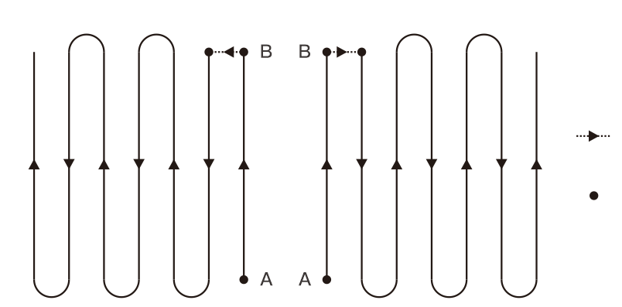
Turining point
Spray width
Figure 2-3-5 AB point spray route

Operation steps
Step 1. After taking off, the UAV flyies to the position of the point A (usually set at the head of the site). Click the button “” and the plant protection assistant APP indicates that the point A is recorded successfully by the voice prompt. The blue light of the button “” is always on.
Step 2. The UAV flies to the position of the point B (usually set at the end of the site). Click the button “”and the plant protection assistant APP indicates that the point B is recorded successfully by the voice prompt. The blue light of the button “” is always on.
Step 3. Click the button "AB", at this time, the plant protection assistant indicates that entering the AB point mode by the voice prompt. The blue light of the button "AB" is always on.
Step 4. The UAV receives the command from rolling joystick on the remote controller changing to the line left/right, and the UAV will operate corresponding direction.

Exit AB point
The points A and B can be exited by the following methods:
1. Enter the obstacle avoidance hovering mode.
2. Brake the UAV for emergency, records the breaking point and hovers.
3. During the AB point operation, click the button "AB" buttons on the remote controller (The blue light is off) and exit the AB point operation mode, and the UAV will hover. If the button "AB" buttons on the remote controller is clicked again, the UAV will fly directly to the breaking point or projection point and continue to operate (Returning to the breaking point or projection point can be selected by the plant protection assistant APP).
Special considerations:
1. During the operation, it is necessary to ensure that the UAV is in sight.
2. Accessing the signal of GNSS is in normal condition and the AB point can be recorded without breaking pesticide point.
3.The distance between the points "A" and "B" should be greater than or equal to 10 meters.
4. During the operation, the current altitude can be maintained by controlling the throttle passage according to the actual situation. When the throttle is in the neutral position, the UAV will maintain the current altitude.

Auto flight mode

introduction
Brief introduction of the mode
Users can measure the farmland and obstacle, and set the navigation point through the planning field system of the plant protection assistant APP. The plant protection assistant APP will calculate and generate the best route to realize intelligent operation planning. This mode is suitable for large or irregular plots. The operation route of fully autonomous operation mode is shown in Figure 2-3-6. In the figure, the dotted line length is the operation space. It can be set in the plant protection assistant APP.

Line changing points

作业起始点
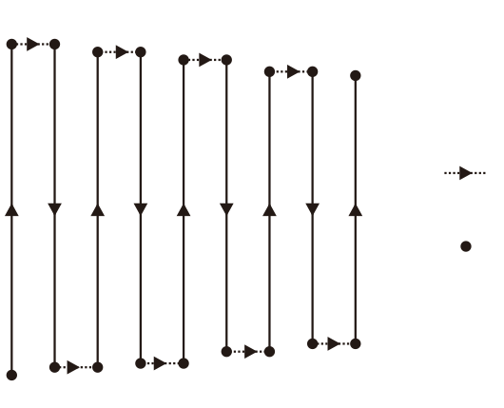
Spary width

Line changing points

Figure 2-3-6 auto flight route

Operational steps for measuring the plot
Step 1: Open the plant protection assistant APP, there are three options, including GPS plotter mapping, UAV measuring or RTK measuring according to the situation of the plot to be measured.
Step 2: Set the name of the plot.
Step 3: Measure the boundary points, select the boundary points at the inflection points of the boundary of the operation area.
Step 4. Obstacle point: If there is an obstacle in the planned block, click on the obstacle points and select the shape of the obstacle area, then hit the obstacle points at the inflection points of the boundary of the obstacle area, and click on the confirmation of the obstacle points after editing.
Step 5. Reference point setting: After the compeletion of editing the operation area, reference points need to be added. Reference points are used for the map rectification. When setting reference points, it is confirmed that the characteristics of reference objects are obvious and the position is spacious, which is suitable for the takeoff of the UAV. After setting reference points, the addition of the block is completed.

fully auto flight steps
Step 1: After the plant protection assistant APP connects the UAV, expand the land/task list on the main interface;
Step 2: Select a block (or a block in the task list) and click on the calling of the block.
Step 3: Place the UAV at the reference point of the block, click to correct the offset, and click "Correct to the position of the UAV"
Step 4: In the interface of calling the block, the following operational route parameters are sequentially planned: route angle, turning mode, route inner contraction, obstacle point space, altitude, usage per mu, and way of bypassing the obstacle area.
Step 5: Select the route to be sprayed according to the situation of the route (The default is full selection);
Step 6: Click on the operation interface to start the operation.
Step 7: Slide to unlock, the UAV will take off automatically and execute the planned route.
Step 8: Complete the operation (The user can manually click the ending the operation on the way of the operation) and generate the operation report

Special considerations:
1. During the operation, it is necessary to ensure that the UAV is in sight.
2. During the operation, the throttle lever of the remote controller can be manipulated to adjust the flight altitude according to the crop condition. When the throttle lever returns to the median position, the UAV will resume its altitude setting.
3. For more detailed operation, please refer to the " User manual of the plant protection assistant APP "

Function introduction

remain liquid

Function instruction
F16 is equipped with a standard continuous level meter, which can detect the residual dosage in the medicine cabinet and display it to the user by percentage. In the operation process, the residual dosage and the length of the route can be combined to select a reasonable breakout location, so as to reduce the air flight of the aircraft and improve the operation efficiency.
the red mark is remain liquid warning at app
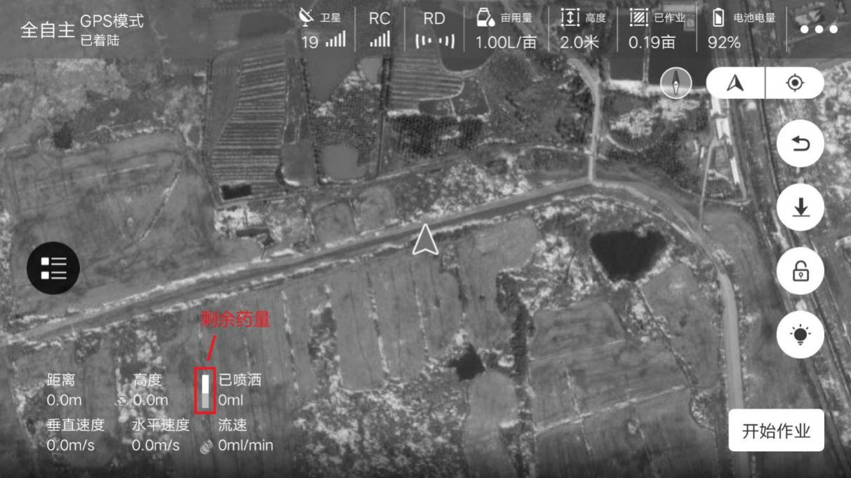

Continuous spraying at the breakpoint

introduction
If there are the reasons of the pesticide breakage, low battery capacity, emergency braking, obstacle avoidance and so on during the operation and the user needs to continue to work along the established route after the breakage point is recorded, the user can return and continue the operation through the function of continuous spraying at the breakpoint.

Record the pesticide breakage point
During the operation, the UAV will record the pesticide breakage point and can perform the continuous spraying at the breakpoint when the following circumstances occur:
1. The amount of the pesticide is insufficient in the operation tank.
2. When the low voltage protection is started, the first level low voltage protection is triggered.
3. The remote controller operates with the joystick in pitch or roll direction.
4. When the UAV enters the return flight in any way.
5. When the UAV is equipped with obstacle avoidance, it detects the obstacle and stop automatically.
6. If the signal of GNSS is weak, the UAV will automatically switch to the attitude mode and record the current coordinate point as the pesticide breakage point.
7. Click the button "pause" in the plant protection assistant APP.

Special considerations:
1. Whenever any of the above conditions are met, the UAV will update the pesticide breakage points.
2. The following actions can be set for the UAV according to the operating environment after the execution of the pesticide breakage points: hovering, raising by 2 meters and hovering.

Return to the pesticide breakage point
The steps for returning to the pesticide breakage point are as follows:
Step 1: Manually manipulate the UAV to UAVor in any open place to ensure that there is no obstacle between this position and the position of the pesticide breakage point.
Step 2: In the plant protection assistant APP, click the button "Return to the pesticide breakage point " or click the button “” of the remote controller.
Step 3: Select "Return to the pesticide breakage point" or "Return to the projection point" in the plant protection assistant APP.
Step 4: The UAV automatically rises or falls to the operating altitude and returns to the pesticide breakage point.
Step 5: Resume the set route and continue the operation.
Special considerations:
1. For more detailed operation, please refer to the " User manual of plant protection assistant APP

Return to shadow point
When you are confronted with obstacle, you can choose return to shadow point.
Step 1: After the operation is interrupted, manually steer the aircraft around the obstacle;
Step 2:Click the bottom right corner of the APP to continue the operation, select return to the shadow point, and 1, 2, and 3 options will appear, corresponding to no. 1, 2, and 3 points identified in the airline;
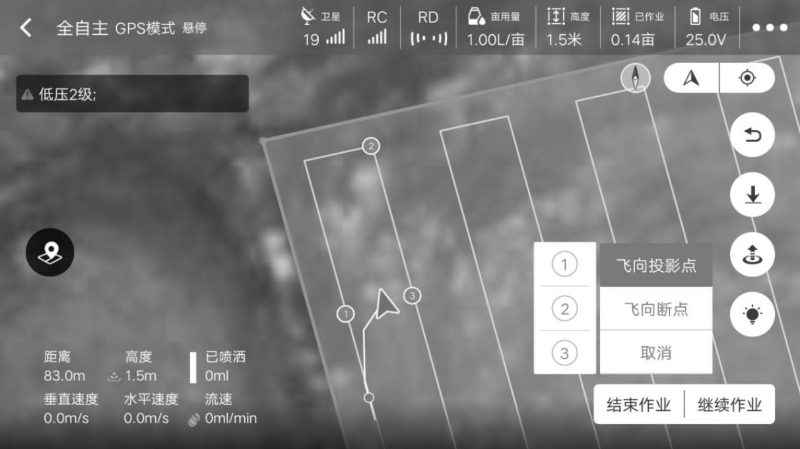
Step 3: Click the option of a certain point, and the aircraft will fly to the point to continue operation;

Terrain follow radar

Introduction
The optimum altitude range of terrain-following radar is between 1 and 10 meters. After the terrain-following radar is turned on, the relative height of the UAV and the crops can be kept unchanged during the operation, and the terrain-following can be realized to ensure the uniformity of the spraying of the pesticide liquid. The operator closes or opens in real time through the button "radar switch" of the remote controller.

Sensitivity setting
The sensitivity of the terrain-following radar can be adjusted to adapt to different crops during the operation, according to crop types, such as corn, rice, wheat and so on.
1. Any sensitivity setting is greater than 90, which indicates that the simulated terrain strongly follows the terrain, and the upper and lower sensitivity represents the percentage of maximum following coefficient.
2. Both upper and lower sensitivities are not greater than 90, which indicates that the simulated terrain is weak in following the terrain. The terrain-following sensitivity begin from 60, and the maximum value is 40% of the maximum following coefficient.
Special considerations:
1. The radar module cover should not be collided or extruded.
2. The radome of the radar should be kept clean, and the soft wet cloth should be used regularly to wipe the surface according to the frequency of attendance.
3. Use cautiously when the UAV fly above the surface of an object with A slop greater than the following values. Taking the sensitivity as an example, the relationship between the simulated slope and flight speed is as follows: 10 degrees (4.0m/s), 15 degrees (3.5m/s) and 20 degrees (2.5m/s).

Low battery capacity protection
The UAV has the function of low battery capacity protection. The user can set the trigger threshold of protection (percentage of battery capacity) in the plant protection assistant APP. After triggering the threshold, the UAV will execute the action according to the setting. The action can be set as: hovering in place, landing in place, returning, no action (only flash prompt).

Low battery capacity protection

UAV’s indicator blinking the red lamp is the first-grade low battery warming. The user shall fly the UAV to the safety area to land and then change the battery. The factory default first grade low battery limitation is 30%. The executive action is no action (red light blinking) and plant protection assistant APP will deliver voice prompt about low battery.

Secondary Grade Protection

UAV’s indicator blinking the red lamp is the first-grade low battery warming. The user shall fly the UAV to the safety area to land and then change the battery. The factory default first grade low battery limitation is 10%. The executive action is landing (red light blinking) and plant protection assistant APP will deliver voice prompt about low battery.
Special Remarks:
1, After launching the low voltage protection function, it only could be switched into the attitude mode or reversal course mode.
2, After launching the automatical landing function of low voltage protection, it could quit the protection action through switching into the attitude mode.

Fail Safe
2.4.4.1 RTH
During the taking off or the flying process, when the GPS signal reaches the seven stars for the first time and the signal quality is good, the UAV will remark the current point as the RTH point. The process for UAV automatically returning to the RTH point is called RTH.

Protection Logic
When GNSS signal is good and the compass work normally, after successfully recording the course reversal point, if the lost the remote-control signal by any reason during the work process, the UAV will adopt protection measures. The protection measures include: landing, hovering and returning to the original place.
Special Remarks:
1, With non-missing condition, during the automatical course reversal process, the UAV could cancel course reversal by dialing the driving lever of remote controller to “S” level as well as obtain the control right of UAV;
2, With non-missing condition, during the automatical course reversal process, the UAV could cancel the course reversal by holding the “” button for 2 seconds.

Front and Back Obstacle Avoidance (Optional)
Tieing with the new 77Ghz millimeter wave radar, the UAV could detect the obstacles without the influence of the ambient light and dust. Under the qualified operation conditions, it is predictable the front and back obstacles of the UAV. The farthest detectable distance could reach 20 meters. When confronting the obstacles for operating, the UAV will be controlled automatically so as to guarantee the operation security. The radar obstacle avoidance function is default as open which is also selected to turn off the plant protection assistant APP.

Detection Scope
As shown in the following picture, it is the detection scope of the radar module. The vertical direction is 0° to 15°, as shown in Figure 2-4-1 and the horizontal direction is ±45° as displayed in 2-4-2. If the obstacles locate out of the detection scope, the radar module could not detect the obstacles and it shall fly cautiously.

Figure 2-4-1Vertical Direction View

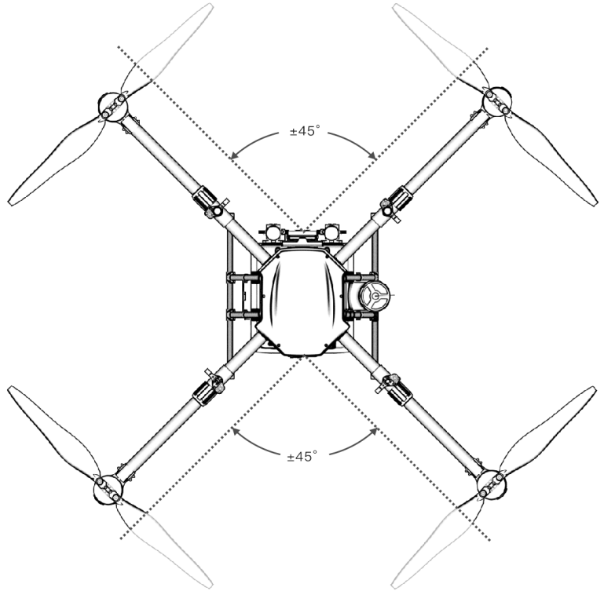
Figure 2-4-2 Horizontal Direction View

State Description
The distance between aircraft and obstacles is X

X≥18M 18M≥X≥8M X＜8M
State 1: When the obstacle is far away 18 meters and above, the UAV is no brake and the APP has no abnormal display;
State 2: When entering the yellow early warning area, the UAV start to decelerate to 1m/s and to maintain with this speed. APP would express the yellow obstacle data;
State 3: When entering into the red early warning area, the UAV will adopt the urgent brake till marching into the “safety mode”. After entering into the “safety mode”, it will keep hovering situation and stop flying toward the obstacles. The APP would display the red obstacle data. When manipulating the UAV to fly to the opposite direction of the obstacles, the UAV “safety mode” could be relieved.

execution logic
- After launching the obstacle avoidance function, when the UAV locating the “S” flying mode or landing situation, the obstacle avoidance would be prohibited;
- After launching the obstacle avoidance function, in order to leave the enough brake distance, please limit the max rate under 6m/s;
- After launching the obstacle avoidance function, the pitch angle amplitude limiting is 10°. Only under obstacle avoidance deceleration or braking conditions, it could be maintained between 10° and 25°. The backward obstacle avoidance sensor data is normal. When the UAV’s flying speed backwards is larger than 0.2m/s, it will switch to the backward obstacle avoidance;
- Front obstacle avoidance sensor data is normal. When the UAV flying speed is larger than 0.2m/s, it will switch to the front obstacle avoidance;
- When the UAV locating the hovering situation, if the distance of the front obstacle is farther than 18m, it will regard no obstacle and the front obstacle avoidance is 0.
- If the distance of the front obstacle is between 8m and 18m, it suits to the rate limiting condition. When the forward speed is larger than 1m/s, the forward speed will be braked to 1m/s. When the forward speed is less than 1m/2, the forward speed is limited to 1m/s. The front obstacle avoidance grade is 1. After generating 0.2m/s backward speed, it could be relieved;
- If the front obstacle distance is less than 8m, the UAV would brake to stop immediately and enter into the “safety mode”. The front and right-left direction are uncontrolled. When the front obstacle avoidance grade is 2, after generating 0.2m/s backward speed, it could be relieved;
- Under the flying mode of GPS mode, during the landing process, when the horizontal direction speed is less than 1m/s, the UAV is allowed to trigger the brake for 5 m away from the obstacles, it will enter into the “safe mode”;
- The backward obstacle avoidance logic and forward obstacle avoidance logic is consistent;

2.4.5.4 Classic Scene Description of Obstacle Avoidance
Alive Tree, Telegraph Pole: within 20 meters, the obstacle avoidance radar could detect the obstacles and continuously display the warning data. When the distance is less than 18m, the UAV will adopt the braking so as to ensure the safety of UAV.
Cable: Taking the cable which is with 1.5cm diameter as example, because the cable radar reflection effect is poorer, when the UAV radar approaching the cable by 3m/s speed, the UAV would find the obstacle in about 13 meters away. The thinner cable or higher-flying speed, the poorer obstacle avoidance.
Special Remarks:
1. Applying the radar module in line with the local wireless control and law regulations.
2. Targeting to different size and texture obstacles, the efficient work scope of the radar module would be different to some extent. For example, for the pedestrians, across electric wire, dried branches, needle plants, the perceptive distance would be declined, please operate cautiously.
3. The radar module suits to the flat environment. When applying it to the scene with larger gradient, the error phenomena will be generated.
4. When the body surface beneath the UAV is less than 1.5m, it is easy to cause the error report.
5. Do not remove the radar module by yourself. Avoid the abnormal of radar module function for irregular installation of radar.
6. Prohibiting to collide or squeeze the shell of radar module.
7. The radar module could be used normally under the rainy days but its radar detection performance would reduce 10% to 20%.

RTK Function (Optional)

Introduction
Carrying the RTK module, the T410 could obtain the centimeter-level positioning as it works to improve the precision of agricultural plant protection. When launching RTK and GNSS signal is good, the UAV will start double antenna direction finding function which not only enjoys a high orientation precision but also could fly reliably under the high-voltage power lines, metal building and other strong magnetic interference enviroment.

RTK setting at drone
Step 1: Stand base station,refer to step 2.4.6.3 set as base mode；
Step 2: Click the satellite status in the top bar of the main interface to enter the RTK setting interface;
Step 3: Set the data source as "data link". After the base station is successfully connected, the RTK state can be viewed, and the operation can only be done when the display is "fixed point".

RTK base station setting
Step 1: turn on base station, wait search GPS satellites.
Step 2 : Click the satellite status in the top bar of the main interface to enter the RTK setting interface;
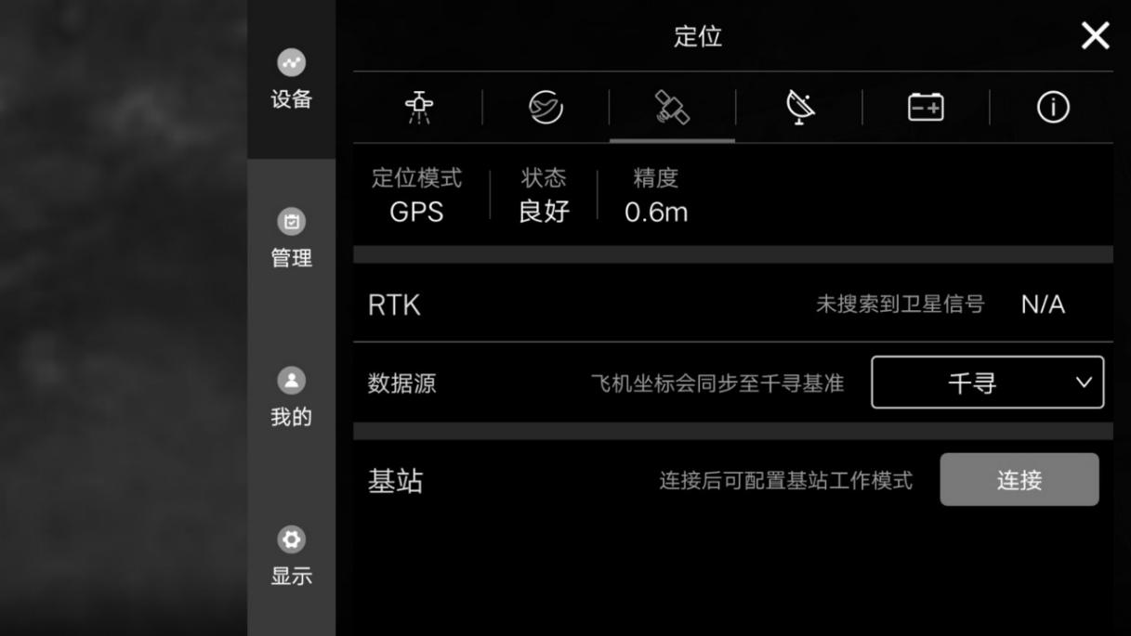
Step 3: Click the connection button in the status bar of the base station and select the Bluetooth address of the corresponding RTK base station.
Step 4: After successful connection, click the configuration button to configure into the following two modes:
A.Dot pattern: accurate mapping of the plot;
B. Base station mode: provide precise positioning service for the uav in operation;
Step 5: After selecting the mode, the RTK system can work normally when "fixed point" is displayed.
Special Notes:
- 1. Please adjust the base station level when setting up the base station and ensure that the height is higher than the crops in the operating area;
- 2. Do not move the base station during aircraft operation;
- 3. In order to ensure the signal quality, it is suggested that the antenna of the base station point to the sky and keep perpendicular to the ground;
- 4. In order to ensure the communication quality between the base station and the aircraft, there must be no shielding between the base station and the aircraft.

3 Maintenance & Common Fault Elimination

3.1 Remote Control Maintenance & Announcements
- The remote control shall be wiped regularly so as to keep clean and away from the water and liquor;
- Please fold the antenna after using it so as to avoid the damage of antenna;
- If the rocker locates the neutral point, the UAV could not be hovered and would keep moving in the same direction. The rocker of the remote control shall be calibrated.

3.2 Airframe Maintenance & Announcements
- The airframe contains the compact electric parts. When cleaning, it shall wipe by the warm water and soft cloth. Avoiding washing it by high pressure waterflow;
- All screws in the connection parts shall be tightened and the screw tightness degree shall be examined regularly;
- The front and back strainer of the UAV could filtrate the water drops and ventilate. The mask for ventilation shall be changed at regular terms so as to aircraft internal ventilation and heat dissipation;
- During the transportation procedure, please keep the motor of folding machine arm on the folding structure.

3.3 Motor Maintenance & Announcements
The agricultural plant protection motor work condition is poor as well as the mist, liquor and farm chemicals are the major elements for damage. Hence, the following notes shall be done:
- After using, please apply the warm and soft cloth to clean the motor surface. Avoiding wash, the motor by running water or water pipe directly so as to avoid damaging the motor;
- Periodic rotate the motor by hand. The large resistance and noise represent that motor is polluted or bearing failure.

3.4 Propeller Maintenance & Announcements
- Replacing the cracked or damaged propeller;
- The installation of propeller shall keep tightly in the horizontal and vertical directions.
- Must clean the farm chemical residues after using.

UPS maintenence

UPS battery

spec
No. | Item | Spec
1 | Model | Lipo can charge
2 | Each cell | 11.1V
3 | capacity | 2500mAh
4 | discharge | -20℃~55℃
5 | charge | 0℃~45℃
6 | storage（within 3 months） | -5℃~35℃

attention
- If the drone is at stock, you need charge the drone per month, charge the drone 20min at least, in order UPS discharge.
- Dont take out the UPS battery
- Under no circumstances should the battery be put into the fire, otherwise it will cause the battery to burn.
- Do not immerse the battery in liquid, such as fresh water, sea water, beverage, etc.
- Dont use broken battery

Battery Maintenance
- Please time and charge slowly which is favorable of keep battery voltage balance;
- Avoiding charging under high temperature condition;
- The fall of battery might cause the short circuit of the battery cell in the lithium battery. The serious conditions would lead to the spontaneous combustion;
- The battery plugs striking lights and turning to black would increase the heat which might cause the UAV failure;
- Ensure whether the battery handle suffer from the deformation of pressure or key. The serious deformation might damage the internal circuit board. It is not recommended to use;
- Whether the battery discharging plugs UAV the corrosion or color variation and the lose of aircraft connection. Above problems might result in the head melting, light striking and other phenomena, it is suggested to clean and change the head timely;
- Checking whether the battery charge line head is corroded or changed the color. The corrosion might lead to the short circuit and spontaneous combustion;
- All wire rod appearances do not UAV the damaged conditions. The serious damages would cause the short circuit and spontaneous combustion. Before application, it is suggested to apply the electricity measurer to examine the voltage balance feature of 12 battery cells.

Storage Instruction:
When storing the battery, it is advised to from a unit by 4 to 6 batteries and the gap between storage unit shall be more than 30 cm.
  - Under any storage conditions, the battery shall be avoided direct sunlight for more than 10 min;
  - For the battery storage environment, please keep the indoor temperature (15-35℃) . If it be stored for long term under the 35℃ and above atmosphere, it will accelerate the aging of the battery. After being stored under 0-15℃ for long term, it might cause the time decline situation. And it would recover the normal condition after using sever times at the normal temperature;
  - The battery storage shall avoid the wet environment. Please preserve it under the dry and stuffiness environment;
  - The battery storage point shall be away from the movable large article so as to avoid the accident injuries.

Transportation Instruction:
- It is advised to store the battery into the temperature resistance or inflaming retarding boxes with cover as well as the quakeproof sponge of battery original package;
- Avoiding the charing wire overlapping the edge of the box to cause accident injuries or short circuit;
- For operating, if the battery is placed within the carriage, it shall keep away from the direct light and maintain the ventilation. With the direct light, the sealed carriage would cause the temperature to rise over 80 ℃ which might lead to the battery combustion.
Emergent Treatment Instruction:
The site selection for battery storage, transportation and application shall be equipped with sufficent fire protection sand, fire extinguisher and proximity gloves. If find the battery smokes or combusting, please adopt the following measures immediately:
- Battery starts smoking (or issuing the adust smell): please judge the short circuit position, lift (whether need to wear proximity gloves in lint with the necessary judgement) battery handle or charging lines to drag the battery out of the house immediately and then apply the fire protection sand to bury the battery ( if the charge-dischage wire smokes, the users also need to bury the wires). Please note to take out the battery after cooling totally (otherwise, the battery will continue to smoke).
- Battery generates dense smoke: immediately adopts the fire protection sand, fire extinguisher to put out the fire or bury the spontaneous combustion battery. At the same time, the surrounded batteries and other flammable objects shall be removed quickly. Of the surrounding flammable and combustible objects (liquids), please use a large amount of water to put out fire and cool the temperature immediately.
- Battery confronts the open fire: please utilize lots of water, fire extinguisher or fire protection sand (please turn off the surrounding the power supply of the surrounding electrical facilities firstly and timely) as well as remove the surrounded batteries and other flammable and combustible objects.
Special Remarks:
1、 When applying the fire fighting devices to put out the fire, please abide by the requirements and regulations of the local fire department strictly.

3.6 Plug Connection Maintenance & Announcements
- When connecting the plug, please insert it totally, otherwise, the plug will heat and affect the flying security;
- If the fuselage battery socket and battery plug turn to black or strike light, please change them on time.
3.6.1 Fog System Maintenance & Announcements
- After using, please inject the clean water into the medicine chest, pipeline, shower nozzle to clean them;
- Avoiding using after mixing the weed killers and pesticide to cause the damages to the crops;
- Please clear the operating box for the long term storage and transportation state;
- Forbidding water pump no-load high-speed operating for long term;
- Avoiding using power and high concentration missible oil agentia as it works to prevent blocking the spray channel.

Shipment package
Package size：883mm*883mm*700mm as below
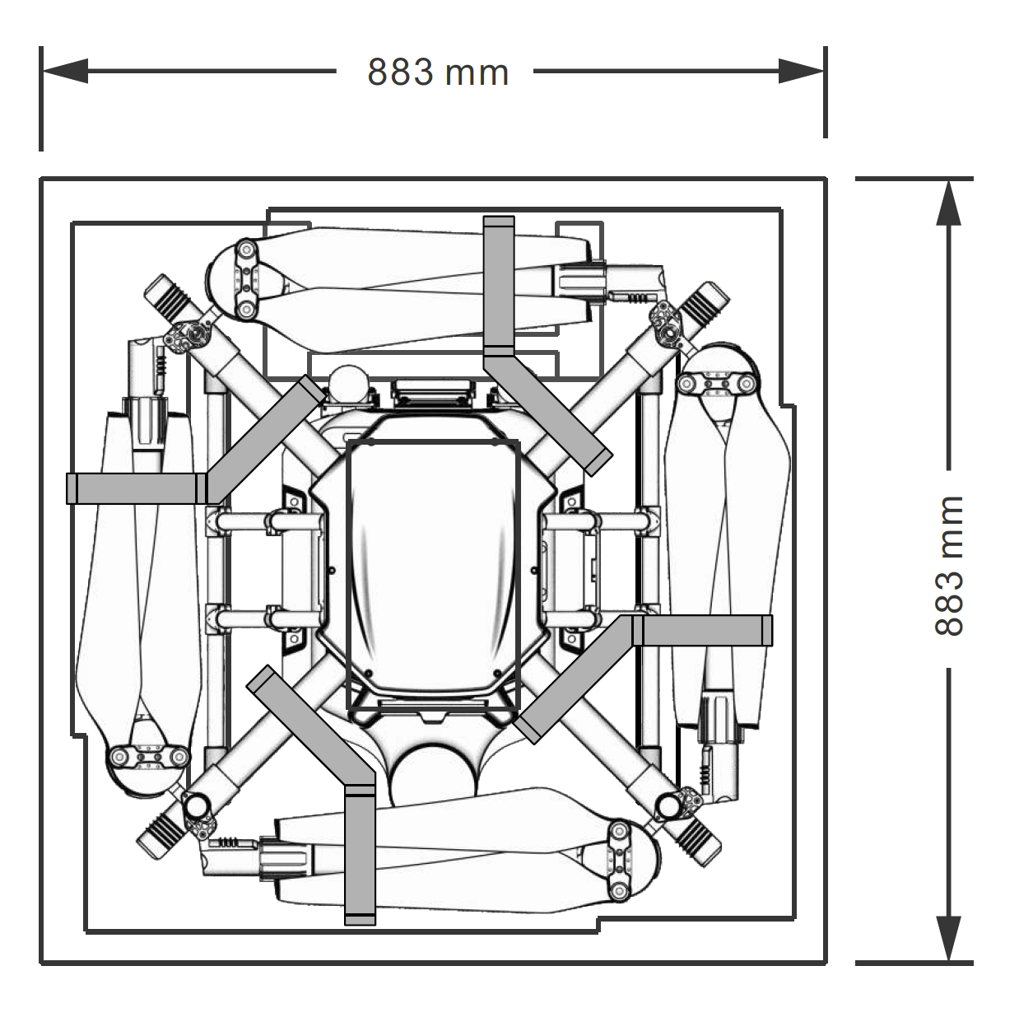
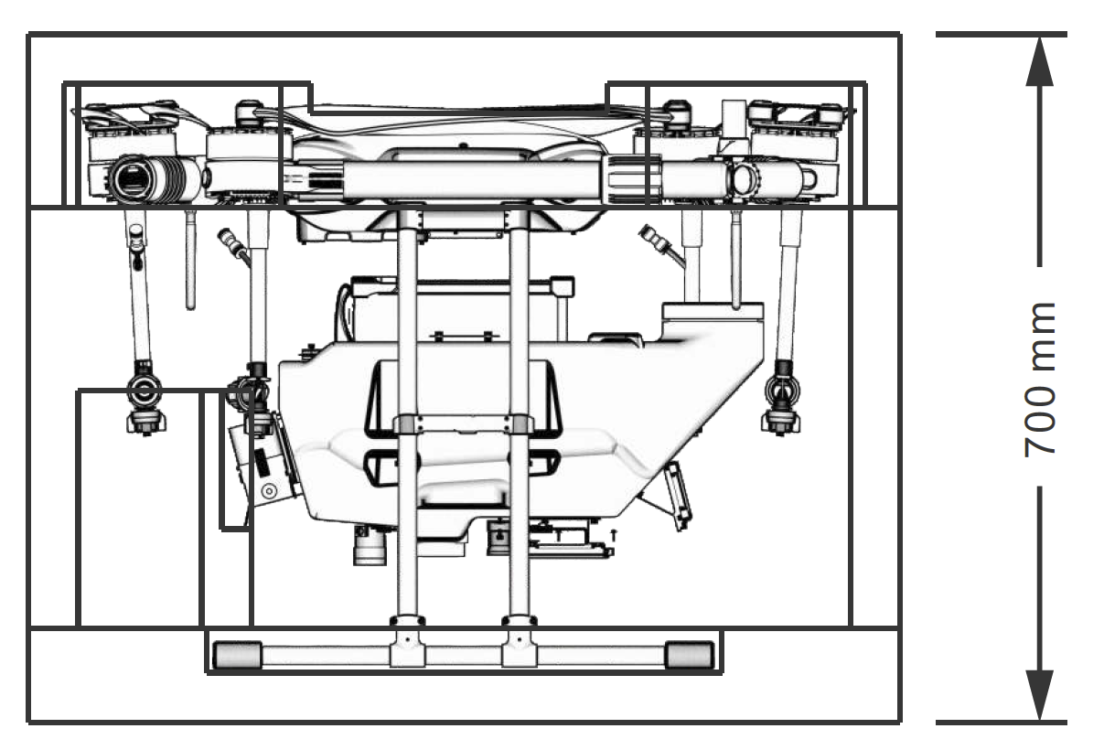

risk and safety list and solution
No | risk | solution
1 | rotating propeller at high speed | When in use, a safe distance should be kept from the aircraft and the aircraft should be kept away from people, animals or other obstacles
2 | Use tank | After use, clean with clean water and cover the outer cover. Store the area that cannot be reached by people and animals.
3 | When charging | Place battery and charger at specific charging area and environment, pay attention to ventilation.And stick good electric shock hazard identification.
4 | battery | The maximum allowable voltage is up to 58.8V. Please use in strict accordance with the relevant safety specifications and the instructions of the battery itself, and be sure to pay attention to safety.
5 | Motor stop suddenly | Do not use the hand to contact the motor immediately, otherwise it may cause burns.Power - off machines should be placed in a ventilated environment as far as possible.
6 | Chemical liquid | In the use of pesticides, it is necessary to pay attention to the dangers of the types of pesticides, and to understand the use of various pesticides measures in advance.
7 | flight | Do not fly in bad weather, such as strong wind (wind speed 8m/s and above), heavy rain (rainfall 25mm or above in 12 hours), snow, fog, etc.

Manufacturer information
Manufacturer：TopXGun (Nanjing) Robotic Ltd,.Co
Address：6 floor, 8th building, Jiyun Building, Jiangsu software park,No.1 Dongji avenue,Jiangning District,Nanjing
Tel：025-83798727

Appendix

Spec
spec | parameter
package
Package size | Package size 883*883*700mm
Net weight | 16.1Kg
Gross weight | 24.0Kg
frame
wheelbase | 1790mm
Arm longth | 786mm（front）；768mm（rear）
Outlook size | 1357*1357*610mm（unfold state）  771*756*575mm（fold state）
dynamic
motor | T80
size | 80x20mm
KV value | 100rpm/V
Maximum tension | 17Kg（1 motor）
Rated power | 4400W（Total power of four motors）；1100W（1 motor）
Weight | 655g
ESC
Rated work current | 40A
voltage | 50.4V（14S LiPo）
Maximum signal frequency | 500Hz
Drive PWM frequency | 20KHz
canbus maximum control frequency | 2KHz
Unflod propeller
material | Polymer + carbon fiber
diameter | 36 inch
pitch | 11.5 inch
Commonly used pull/speed | 9kg/2100RPM（20℃ below）
weight | 302g
Spray system
tank
capacity | 16L
payload | 16Kg
Battery install position | 245*200*135mm
nozzles
model | 110015VS
qty | 4个
Max spray rate | 2700ml/min（use 110015VS）
Spray width | 4.0~6.5米
Recommand spray height | 2m wth the plant
Atomized particle size | 110015VS：170 - 265μm
Radar system
Terrain radar
modern | FMCW
frequency | 76GHz~77GHz
waterproof | IP67
Height range | 1-20m
Detect accuracy | 0.1m
Avoidance sensor
Detect range | 1-20m
Usage condition | Except attitude mode，filigt height＞1.5m and speed＜6m/s；
Safe distance | 4.5m
Avoidance directionc | Front and rear
waterproof | IP67
FPV camera
FOV | Horizontal 102°，vertical 57°
The resolution of the | 720P
Degree of illumination of the supplementary light | 15lux@5m directly
Power of supplementary light lamp | 6W
Flight parameter
Drone weight（without） | 13.8kg
Take off weight | 37.1kg
Hover precision  （GNSS signal good） | Horizontal ± 1.0m，vertical ± 0.5 m
 | horitontal ± 10 cm，vertical ± 10 cm（with RTK）
 | vertical ± 0.1m（with terrain radar）
Hover time* | ＞10min（full payload）  ＞20min（without payload）
* Hover time is measured near sea level, wind speed is less than 3m/s, and ambient temperature is 25℃.
Max flight speed | 10m/s
Max sea height | 2000m
Recommand work temperature | 0~40℃
GNSS system
Frequency | GPS：L1/L2；GLONASS：L1/L2；BDS：B1/B2
Hover accuracy(RMS) | Without RTK：horizontal：±0.6m；vertical ±0.3 m
 | RTK fix Point：horizontal：±0.1m；vertical ：±0.1m
Position accuracy（RMS） | 0.4°
Communication frequency | ¹*840MHz-845MHz
 | ²*900MHz-915MHz
 | ³*2.400GHz~2.4835GHz
Mapping kit handhold
Accuracy | Signal position： 2.0m CEP50  DGNSS： 0.5m CEP50  RTK： 2cm+1ppm(水平) CEP50
Charge time | ≤4h
time | 4h-8h
Battery capacity | 3000mAh
Waterproof protection | IP65
size | 70*70*50mm
weight | 300g
RTK base station (optional)
Support mode | Base station/click point mode
Use time | 8h
Data link optional | ¹*840MHz-845MHz
 | ²*900MHz-915MHz
 | ³*2.400GHz~2.4835GHz
Signal coverage（without influnence、without shadow） | 4km（840MHz-845MHz）
 | 3km（900MHz-915MHz）
 | 1km（2.400GHz~2.4835GHz）
Water proof | IP65
size | 70*70*50mm
weight | 360g
charger（TC2604）
input | 100V-240V~11A 50/60Hz
output | 2600W
channels | 4
Supported language | chinese
Net weight | 5.85Kg
Gross weight | 6.80Kg
size | 265*150*248mm
Package size | 350*330*245mm
battery（TB1416）
voltage | 51.8V
Discharge power | 15C
protection | IP64
Life time | 300次循环
capacity | 16000mAh
weight | 5.65kg
Package size | 295*275*320mm

